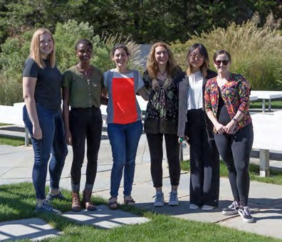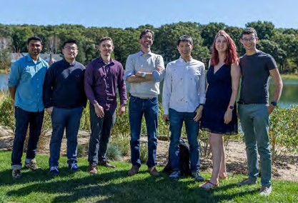

The laboratories of Alfredo Fontanini and Arianna Maffei are recruiting postdoctoral candidates interested in studying the circuits involved in taste and taste learning.

Our groups use complementary approaches – including electrophysiology, calcium imaging, optogenetic, chemogenetic, anatomy and a variety of behavioral assays - to study the neural circuits underlying taste learning, taste-dependent behaviors, decision-making and homeostatic regulation of taste. Research projects are available in each of these areas, and the specific directions will be shaped by the candidate’s interests. Future postdocs could join either one of the two groups or be part of a collaborative project. The groups occupy adjacent space on the 5th floor of the Life Sciences Building and maintain ongoing collaborations and shared projects. The labs culture is welcoming and inclusive, the groups strive to provide a collaborative environment focused on scientific growth and excellence.

The laboratories are also part of the Center for Neural Circuit Dynamics and collaborate with theoretical/computational neuroscientists to determine the mechanisms for metastable network dynamics regulating perception and behavior.

The teams are housed in the department of Neurobiology and Behavior at Stony Brook University (New York), a vibrant and very collaborative Department with interests spanning from molecular to systems and computational neuroscience.

If you are interested, please email:

[Arianna.maffei@stonybrook.edu](mailto:Arianna.maffei@stonybrook.edu) [Alfredo.fontanini@stonybrook.edu](mailto:Alfredo.fontanini@stonybrook.edu)

[https://www.stonybrook.edu/commcms/neurobiology/people/faculty_Arianna_Maffei.php#RecentPublications](http://www.stonybrook.edu/commcms/neurobiology/people/faculty_Arianna_Maffei.php#RecentPublications) [https://www.stonybrook.edu/commcms/neurobiology/people/faculty_Alfredo_Fontanini.php#Publications](http://www.stonybrook.edu/commcms/neurobiology/people/faculty_Alfredo_Fontanini.php#Publications)

or apply online @:

<https://stonybrooku.taleo.net/careersection/2/jobdetail.ftl?job=2103015&tz=GMT-04%3A00&tzname=America%2FNew_York>

Department of Neurobiology & Behavior

